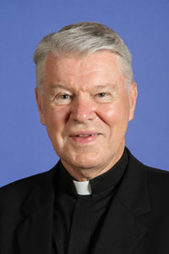
Father Patrick McCormick was born in Erie, Pennsylvania—the youngest of five children of John and Frances McCormick. He graduated from the University of Notre Dame, then entered the seminary under the direction of Msgr. P.J. O’Connor, vocations director of the Archdiocese of Atlanta. He studied at St. Mary’s Spiritual Center on Paca Street in Baltimore, Maryland, then at the Pontifical North American College, Rome. He completed his licentiate in sacred theology at the Pontifical Gregorian University and was ordained in Rome on Dec. 20, 1968.
In the Atlanta Archdiocese, he served as parochial vicar at Holy Spirit Church, Atlanta; St. John the Evangelist Church, Hapeville; and Corpus Christi Church, Stone Mountain. In 1973, Father McCormick was assigned to the North American College in Rome as director of liturgy. In 1977, he returned to the archdiocese and was assigned as pastor of St. Mary Church in Toccoa and Sacred Heart Church in Hartwell, becoming that parish’s first full-time pastor in 1982.
In 1990, he entered active duty with the U.S. Navy, being assigned to a submarine base in Italy, then two aircraft carriers in San Diego. He spent five years in Japan at naval and Marine Corps stations. He was also assigned to Naval Station Pearl Harbor Hawaii, NATO Combined Transition Command in Afghanistan and the Marine Corps Base, Hawaii. Father McCormick retired from active duty in 2010.
He served as a civilian chaplain at Tyndall Air Force Base in Panama City, Florida, then for the army at the Reagan Missile Defense Garrison in the Marshall Islands. He retired in 2017.
Father McCormick is a senior priest at St. John the Apostle Catholic Church in Mililani, Hawaii, and preaches for Cross Catholic Outreach.

